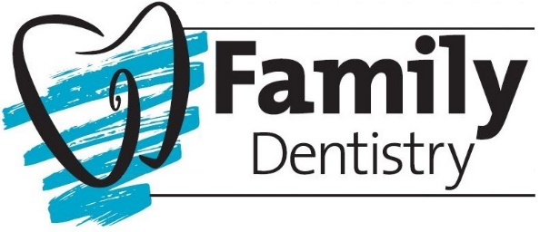

Records Release/Request:

I hereby authorize the release of my dental records and my most recent dental x-rays. Please include a panoramic film it one was taken within the last 3 years. I request they be transferred to (Please circle one):
Saratoga Springs  Family Dentistry  286 Church Street  Saratoga Springs, NY 12866  518.584.8150  Fax 518.584.8751  saratogafd.office@okrinse.com | South Glens Falls  Family Dentistry  63 Hudson Street  Glens Falls, NY 12803  518.792.2187  Fax 518.792.2188  sgf@okrinse.com | Gloversville  Family Dentistry  22 First Ave  Gloversville, NY 12078  518.725.1031  Fax 518.773.4310  gloversville@okrinse.com
Clifton Park  Family Dentistry  983 Route 146  Clifton Park, NY 12065  518.371.3333  Fax 518.952.4331  cliftonpark@okrinse.com | Greenwich  Family Dentistry  2651 State Route 40  Greenwich, NY 12834  518.692.9333  Fax. 518.692.9696  greenwich@okrinse.com | Queensbury  Family Dentistry  453 Dixon Rd Suite 5  Queensbury, NY 12804  518.792.1108  Fax 518.798.4670  queensbury@okrinse.com
** Please mail or fax this form to your previous dentist prior to your appointment. It is very helpful and will save time if your records are available for us at your exam!

Patient Name: ____________________________________________________________________
Patient Signature: ______________________________________ Date: _____________________
Previous Dentist Information:
Dental Provider: ___________________________________________________________________
Address: _________________________________________________________________________
City: ______________________________________________State: ________ Zip: _____________
Phone: _______________________________ Fax: _______________________________________
E-mail: __________________________________________________________________________

