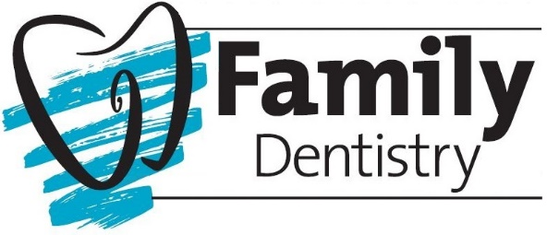

Records Release/Request:

I hereby authorize the release of my dental records and my most recent dental x-rays to:

Dental Provider: ___________________________________________________________________
Address: _________________________________________________________________________
City: ______________________________________________State: ________ Zip: _____________
Phone: _______________________________ Fax: _______________________________________
E-mail: __________________________________________________________________________

Patient Name: ______________________________________________________________
Patient Signature: ________________________________________ Date: _____________

Please circle the office you are requesting your records to be released from:
Saratoga Springs  Family Dentistry  286 Church Street  Saratoga Springs, NY 12866  518.584.8150  Fax 518.584.8751  saratogafd.office@okrinse.com | South Glens Falls  Family Dentistry  63 Hudson Street  Glens Falls, NY 12803  518.792.2187  Fax 518.792.2188  sgf@okrinse.com | Gloversville  Family Dentistry  22 First Ave  Gloversville, NY 12078  518.725.1031  Fax 518.773.4310  gloversville@okrinse.com
Clifton Park  Family Dentistry  983 Route 146  Clifton Park, NY 12065  518.371.3333  Fax 518.952.4331  cliftonpark@okrinse.com | Greenwich  Family Dentistry  2651 State Route 40  Greenwich, NY 12834  518.692.9333  Fax. 518.692.9696  greenwich@okrinse.com | Queensbury  Family Dentistry  453 Dixon Rd Suite 5  Queensbury, NY 12804  518.792.1108  Fax 518.798.4670  queensbury@okrinse.com

